A scientometric approach to antimicrobial resistance forecasting
Michiel Vos¹, STUDENT², Richard Bendall³, Fabrizio Costa²*

1= European Centre for Environment and Human Health, University of Exeter Medical School, Environment and Sustainability Institute, Penryn Campus, TR10 9FE, United Kingdom
2= Department of Computer Science, Faculty of Environment, Science and Economy, University of Exeter, Streatham Campus, EX4 4QF, United Kingdom
3= Kai Ping, Goonvrea, St. Agnes, TR5 0NW, United Kingdom

*= corresponding authors= f.costa@exeter.ac.uk

Keywords: AMR, antibiotic resistance, bacterial pathogens, scientometry, bibliometry, AMR forecasting, Large Language Models, text mining, AMR surveillance

Introduction
Antimicrobial resistance (AMR) is one of the main challenges to global public health, associated with almost 5 million deaths globally in 2019, a number which could increase substantially in the future [1]. A wide variety of measures are in place to control the spread of AMR, including antibiotic stewardship and regulation REF, improved sanitation REF, development of new drugs REF and diagnostics REFs as well as multidisciplinary, OneHealth research efforts REF. A relatively new tool in the combat against AMR is AMR forecasting, which aims to predict future emergence of resistance [2]. AMR forecasting can take different forms, from using pharmacodynamic models to predict resistance evolution [3], to using genomics to predict the potential future dissemination of resistance genes [4], to using timeseries of antimicrobial consumption data to predict phenotypic resistance [5]. Bibliometric approaches have been taken to map past and current AMR publication trends [6-8], but generally these have not explicitly aimed to predict future scenarios.
We describe an AI-assisted scientometric workflow that uses PubMed records to measure scientific attention to pathogen–antibiotic resistance pairs. Synonym-aware searches identify candidate records by pathogen and antibiotic terms together with resistance, nonsusceptibility, susceptibility, or microbial-sensitivity cues. An automated System 1 classifier then assesses whether each title and abstract supports the specified pair. For each pair and year, accepted records contribute to a screened publication count. We compare these counts with the contemporaneous publication activity for each pathogen and antibiotic separately to estimate the Scientific Interest index (AMR-SI) and describe its historical trajectory and projected continuation.
AMR-SI measures attention in the indexed literature, not resistance prevalence, incidence, clinical burden, or transmission. It does not distinguish among definitions of resistance: an abstract may describe gene carriage, phenotypic testing, or results based on different minimum inhibitory concentration thresholds. It also does not identify the lag between detection and publication or record geographic location. The retrieval is not limited to human clinical studies, and a publication may contribute to more than one pathogen–antibiotic pair. The method is intended as a repeatable, updateable view of published research attention that can complement, but not replace, laboratory and public-health surveillance.
We describe the retrieval, screening, and AMR-SI workflow and use selected examples to compare its historical signals with previously reported trends. We then use the fitted trajectories to identify pathogen–antibiotic pairs for further surveillance consideration and compare this prioritisation with pairs included in the World Health Organization Global Antimicrobial Resistance and Use Surveillance System (GLASS).

Methods
Literature retrieval and AMR screening
We queried PubMed for records with publication dates from 2000 through 2026. The active configuration included all 915 pathogen names with a positive pathogenicity index from the ranked pathogen list and all 245 canonical antibiotics. For each entity, synonym-expanded Title/Abstract terms were combined with an AMR/susceptibility clause: the bacterial or microbial drug-resistance and microbial-sensitivity MeSH terms, or Title/Abstract terms for resistance, nonsusceptibility, susceptibility, or antibiotic, antimicrobial, and drug sensitivity. Each candidate record was linked to the queried pathogen–antibiotic pair and assigned a publication year from PubMed metadata. The same PMID could therefore be retrieved for multiple pairs; counts below refer to pair–PMID associations unless stated otherwise. Separate synonym-aware searches for each pathogen and each antibiotic supplied the annual background publication counts. Rows lacking either background count were excluded before model fitting. Pair eligibility required at least 50 screened publications over 2000–2025, at least 10 years with valid counts, and yearly pair counts of at least three when included in the SI fit.

Pooled background-attention model
We estimated the annual screened AMR publication count expected from general attention to the pathogen and antibiotic using one model pooled across retained pathogen–antibiotic–year observations. Counts and background counts were transformed as log10(1 + x) to accommodate zeros and reduce the influence of highly published entities. For pathogen i, antibiotic j, and year t, the fitted model was
- log10(1 + Cᵢⱼₜ) = α + uᵢ + vⱼ + βₚ log10(1 + Bᵖᵢₜ) + βₐ log10(1 + Bᵃⱼₜ) + εᵢⱼₜ,
where Cᵢⱼₜ is the screened AMR publication count, Bᵖᵢₜ and Bᵃⱼₜ are the pathogen and antibiotic background counts, α is the intercept, and uᵢ and vⱼ are pathogen- and antibiotic-specific effects. Pathogen and antibiotic identities were represented by one-hot indicator variables. All coefficients were estimated jointly by ridge regression with penalty parameter αridge = 1. Regularization stabilized estimates across the many categorical indicators and sparsely represented pairs. Back-transformed expected counts were calculated as 10ʸ̂ − 1 and truncated at zero.

Scientific Interest index
Scientific Interest (SI) was defined on the same base-10 logarithmic scale as the residual from the pooled model:
- SIᵢⱼₜ = log10(1 + Cᵢⱼₜ) − ŷᵢⱼₜ,
where ŷᵢⱼₜ is the expected log count from the pooled background-attention model. A positive SI indicates more pair-specific AMR literature than expected from the publication activity on pathogen and antibiotic separately; negative SI indicates less pair-specific AMR literature.

Temporal modelling and extrapolation
Temporal models were fitted separately for each pathogen–antibiotic pair. A degree-one LOESS smoother with span 0.6 was applied to the annual screened AMR counts after log10(1 + x) transformation. SI itself was not smoothed directly. Instead, a second LOESS curve with the same settings was fitted to the annual expected log counts from the pooled model. Predicted SI at year t was then derived as the difference between the smoothed pair-specific count trajectory and the smoothed expected-count trajectory:
- SÎᵢⱼₜ = Ĉᶫᵒᵍᵢⱼₜ − B̂ᶫᵒᵍᵢⱼₜ.
This count-first construction preserves the interpretation of SI as excess publication activity relative to a contemporaneous background baseline. At least three observed years were required for a pair-level fit. If the LOESS implementation was unavailable or could not fit a curve, the software used a linear regression on the transformed counts as a fallback.
For extrapolation beyond the fitted interval, each LOESS curve was extended from its final fitted value using the slope between its last two fitted annual values. The 2030 forecast extends the curve fitted through 2025 from its 2025 reference value; no tail damping was applied. Because linear continuation on a logarithmic scale can imply rapid multiplicative growth, these forecasts are trend projections rather than calibrated epidemiological predictions.

Validation, uncertainty, and prioritization
To assess short-term extrapolation, an auxiliary ranking model was fitted through 2023 and evaluated against the complete post-fit years 2024 and 2025. The workflow recorded absolute and percentage errors for SI and publication counts. Within-curve fit was summarized as the mean squared difference between observed and smoothed SI over the curve-fitting interval. For visualization, empirical bands were formed by adding and subtracting one sample standard deviation of the training residuals around the LOESS log-count curve; the same residual spread was propagated to the derived SI curve. These bands describe residual variation and are not confidence or predictive intervals. Forecast pairs were ranked by predicted SI change from 2025 to 2030. The strict shortlist required predicted publication counts of at least 10 in both years, at least 15 observed screened publications in 2025, an SI increase of at least 0.01, at least one post-fit validation year, and mean absolute percentage SI error no greater than 100%. The saved shortlist contains 127 pairs, all of which passed the strict filters; the configured fallback was not used.

Results
Automated retrieval of PubMed-indexed abstracts on AMR in pathogenic bacteria
The active collection configuration uses synonym-expanded Title/Abstract searches for 915 pathogen names and 245 antibiotics, together with a resistance and susceptibility clause, across publication years 2000–2026. The current saved candidate snapshot contains 514,470 pathogen–antibiotic–PMID associations covering 128,007 unique PMIDs and 21,435 observed pairs. These association counts are not counts of distinct abstracts because one PMID may be associated with several target pairs. The saved candidate output contains 97,575 pair–year rows.
Screening used the active System 1 route with Jev model typesafe/jev-1.13 (served model recorded as typesafe/jev-1.13-20260917), question version amr-pair-support-noul-v1, and run ID jev-1.13-amr-support-v1. Successful predictions matched to the current candidate set were retained at p_yes ≥ 0.75. Joining on PMID, pathogen, antibiotic, and year yields 306,718 accepted pair–PMID–year instances, represented by 64,721 pair–year rows across 15,539 pathogen–antibiotic pairs. The saved SI output contains 644 eligible pairs across 58 pathogens and 96 antibiotics.
[These counts describe the current saved outputs before refreshing the cached PubMed intervals to apply the updated AMR/susceptibility query. Regenerate the collection and downstream screening and SI outputs, then replace the counts and add the final run date before submission.]
Figure 1 summarizes candidate retrieval, pair-level System 1 screening, and SI eligibility. It reports pair–PMID associations separately from unique PMIDs because a single record may be linked to multiple target pairs. The PubMed corpus is the search universe; the project queried matching records rather than downloading and locally filtering the entire corpus.
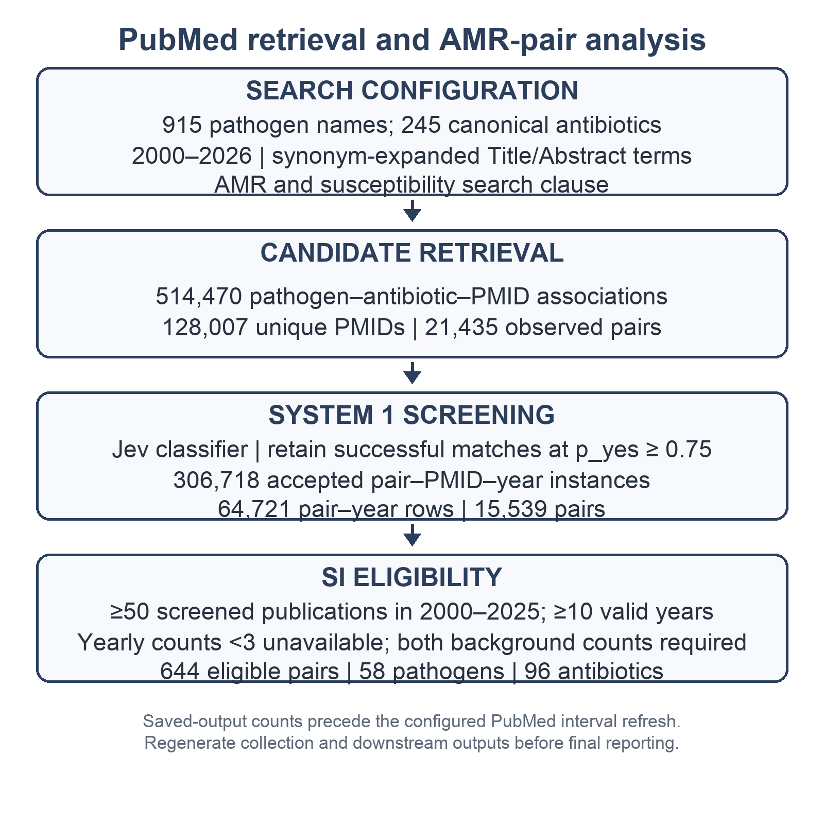

Figure 1. PubMed retrieval and AMR pair screening. Counts in the current saved outputs are 514,470 pathogen–antibiotic–PMID associations (128,007 unique PMIDs; 21,435 observed pairs), 306,718 accepted pair–PMID–year instances after System 1 screening, and 644 pairs eligible for SI analysis. A PMID may contribute to more than one pair. The retrieval and downstream outputs require regeneration after the configured PubMed interval refresh; counts should be updated from that final run.
An automated measure of scientific interest in antibiotic resistance recapitulates known trends
For each eligible pathogen–antibiotic pair, we calculated annual AMR-SI from the screened publication count after controlling for overall publication activity mentioning the same pathogen and antibiotic individually (Methods). Eligibility required at least 50 screened pair publications over 2000–2025, at least 10 valid years, and available pathogen and antibiotic background counts; annual pair counts below three were treated as unavailable. In the saved output, 644 pairs met the SI criteria. Positive AMR-SI indicates more pair-specific AMR publication activity than expected from the separate background counts; negative AMR-SI indicates less. The index measures scientific attention, not resistance prevalence or clinical burden.
Plotting AMR-SI over time captures well-established trends in resistance evolution. DESCRIBE 4 GOOD EXAMPLES OF CONTRASTING TRENDS HERE, REFER TO OLDER PAPERS DESCRIBING THESE SAME TRENDS

Figure 2.ABCD four distinct species-antibiotic trends.

Past and current scientific interest can be used to predict future trends
The ranking model was fitted through 2023, assessed against 2024 and 2025, and used to identify pairs whose fitted SI trajectory could be projected from the 2025 reference year to 2030. The strict shortlist required predicted counts of at least 10 in both 2025 and 2030, at least 15 observed screened publications in 2025, SI growth of at least 0.01, at least one post-fit validation year, and mean absolute percentage SI error no greater than 100%. The saved strict shortlist contains 127 pairs; no fallback pairs were added.
EXPLAIN FIG 3
Explain discrepancies with GLASS list

Figure 3. AMR-SI predicted for 2030 applied to X pathogen species-antibiotic pairs with TRESHOLD HERE.

Discussion
International surveillance is a crucial tool in efforts to contain the spread of AMR, allowing monitoring changes in specific resistance prevalences over time, detecting emerging threats, identifying high-risk pathogen species, resistance genes and transmission pathways, help develop evidence-based treatment recommendations and update national prescribing guidelines REFS.
Recap and novelty
By enabling early detection, tracking dissemination, informing clinical practice, guiding policy, and coordinating international responses, surveillance is one of the foundational pillars of efforts to contain the AMR crisis. Without robust international surveillance, resistant pathogens would spread largely undetected until they become established, making outbreaks more difficult and costly to control.
Our literature-based approach is completely separate from standardised, clone-by-clone lab analyses complete with details on patient, location and date and could never supplant it, but it could complement it.
AMR surveillance data are based on resistance profiles from hospital- and other laboratories by public health agencies which aggregate and analyse the data for trends and outbreaks. After expert review and interpretation this data is then shared through networks such as the World Health Organization Global Antimicrobial Resistance and Use Surveillance System (GLASS) REF,

Caveats:
Miss papers that only mention antibiotic class
Bad paper = bad llm performance, ask Richard example
Quality LLM
Moreover, abstracts can refer to a single strain or collections of strains,
Resistance is resistance, so E coli vancomycin resistance is counted as well
Data is fuzzy but trends shine through
Future modifications
Conclusion From eminence to evidence based science

